gc_logo_small

\_\_\_\_\_\_\_\_\_\_\_\_\_\_\_\_\_\_\_\_\_\_\_\_\_\_\_\_\_\_\_\_\_\_\_\_\_\_\_\_\_\_\_\_\_\_\_\_\_\_\_\_\_\_\_\_\_\_\_\_\_\_\_\_\_\_\_\_\_\_\_\_\_

**Planning for After-Death IRA**

**Distributions**

© 2016 Greene Consulting Associates, LLC INTENDED SOLELY FOR USE BY REGISTERED USERS NOT TO BE REPRODUCED OR CIRCULATED

## ABOUT GREENE CONSULTING ASSOCIATES, LLC

Greene Consulting Associates was founded in 1979 and provides consulting and training services solely to the financial services marketplace. Located in Atlanta, Georgia, Greene Consulting has worked with the top providers of investment management and wealth management in both the United States and abroad. Focused on helping firms generate incremental revenue growth through more effective sales and relationship management strategies, Greene Consulting offers customized training programs in Financial Services Sales, a Sales Management program, Presentation Training that integrates proprietary products, and a comprehensive suite of online learning courses related to investments and wealth management.

For more information about Greene Consulting or any of its products and services, write Greene Consulting at Waterstone Building, 4751 Best Road, Suite 450, Atlanta, Georgia 30337. Or, visit the company's website at www.greeneconsults.com.

## Introduction

While IRAs are not necessarily the primary vehicle for wealth accumulation, many clients today have significant wealth in these tax-deferred accounts as a result of rollovers from qualified plans. It is, therefore, important that financial services professionals be knowledgeable regarding IRA opportunities, strategies, and current regulations.

At the core, the regulations governing IRAs are designed to accomplish two primary objectives:

* Simplicity in the regulations governing distributions from these vehicles.
* Flexibility for the participant/IRA owner in making and planning for choices regarding distributions after their death.

## Objectives

This module is designed to provide you with greater insight into the alternatives investors have regarding the distribution of their IRA\* assets upon their death and to provide insight and summary of the regulations that will have an impact on their choices.

|  |
| --- |
| Specifically, the module will further your understanding of:   * The issues that need to be considered when choosing a designated beneficiary for an IRA. * The impact of the regulations for participants who die before reaching their Required Beginning Date (RBD). * The alternatives for distribution of an IRA balance when the owner dies on or after the Required Beginning Date (RBD). * Various planning strategies that can be considered when seeking to extend the life of an IRA. |

***\**** *Henceforth, we will refer to Traditional IRAs as "IRAs" and we will distinguish the specific identity of Roth IRAs. The vast majority of this course material applies to Traditional IRAs since the distribution of after-death Traditional IRA assets is always at least partially income-taxable. After-death Roth IRA distributions are almost always never subject to income tax.*

## What Plans Fall Under these Regulations?

The regulations governing lifetime and after-death distributions from IRAs generally apply to all of the following:

* Individual Retirement Accounts (IRAs), excluding ROTH IRAs
* 403(b) Plans
* Qualified retirement plans, such as profit sharing, 401(k), ESOP, and stock bonus plans
* Simplified Employee Plans or SEP IRAs
* Savings Incentive Match Plan for Employees or SIMPLEs

In general, the regulations apply evenly to all the plans listed and may also apply to others not listed. However, there are some subtle variations and special rules that relate to each particular plan type. For the purposes of this module and simplicity's sake, we will focus our comments on the application for owners and beneficiaries of individual retirement accounts. To limit the scope of the course, we will not cover the beneficiary distribution rules associated with annuitizing an IRA.

## Distributions from an IRA

There are many different situations where distributions from an IRA are required. This module is focused on distributions that are required upon the death of the IRA owner and the planning required for those with significant IRA balances. While relevant in some instances, this module does not deal with the tactics and implications of distributions during the IRA owner's life.

There are two specific occasions when distributions ***must*** occur from an IRA.

|  |
| --- |
| **Required Minimum Distributions (RMD)** |
| In order to limit the time that an IRA (excluding a ROTH IRA) can maintain tax-deferred status, the IRS has enacted rules that require the IRA owner to begin making distributions from an IRA upon attaining age 70½. These rules are tools of the IRS to ensure that the IRA is used for the primary purpose of retirement planning for the owner and his or her spouse. The rules force the IRA owner to take a minimum distribution from the IRA on an annual basis, based on life expectancy. |
| **Death of the IRA owner** |
| The second instance when the IRA must distribute assets is upon the death of the IRA owner, which is the subject of this module. There are numerous options for how the assets are distributed, and the alternatives hinge on the choices made and planning that is done both before and after death. The choice of the designated beneficiary and the distribution choices available to the beneficiary will require some knowledge of the topic. |

## Basic Terminology

Before addressing the rules regarding post-death distributions from an IRA, it is important to make sure that two key terms related to the regulations are clearly understood.

Designated Beneficiary

Any individual or entity (such as a trust or charity) can be named as beneficiary of an IRA, but not all beneficiary choices will qualify as a "***designated beneficiary***." Only a natural person can qualify as a designated beneficiary. If none is named by the owner, then the IRA plan agreement may name a default beneficiary who may qualify.

|  |
| --- |
| **Natural Person**  A natural person is a living human being, as opposed to a legal entity such as a corporation. |

The choice of beneficiary and whether or not that choice qualifies as a designated beneficiary will affect the timing of the distribution of the assets after the IRA owner's death. By naming a beneficiary that qualifies as a designated beneficiary, distributions will be based upon a life expectancy factor, which may allow the IRA to be “***stretched***” out over the beneficiary's life expectancy. However, if the named beneficiary does not qualify as a designated beneficiary, then the potential ability to "stretch" out the life of the IRA is forfeited and the IRA will be subject to income tax sooner rather than later, such as within five years of the IRA owner’s death.

Naming an entity, such as a trust, charity, or estate, does not necessarily cause the loss of a designated beneficiary because of what are known as the "look through" rules. These rules, which shall be discussed more thoroughly later in this course, essentially look through the entity to treat the beneficial owner of the entity as the designated beneficiary. Because of the benefit of being able to stretch out the IRA when complying with these rules, special care should be taken when naming any beneficiary who is not an individual so as to preserve the designated beneficiary qualification. There are several requirements to qualify under the "look through" rules, but having only "natural persons" as beneficiaries of the entity is key.

If more than one primary beneficiary is named, each must qualify as a designated beneficiary or the IRA will be treated as having no designated beneficiary. Failure to accomplish this will limit the distribution options available for the IRA.

Naming the beneficiary may seem to be fairly straightforward. However, careful planning should be made when making the selection. For large IRAs, there are often multiple objectives to consider, such as:

* Charitable intent.
* Integrating the IRA into the overall estate plan.
* Maximization of the tax deferral opportunities available for the beneficiaries upon the death of the IRA owner (i.e., “stretching” the IRA).

In order to help clients plan for the most effective use and ultimate distribution of their IRA assets, this module will discuss the implications of the various beneficiary designations that clients typically make and the advantages and disadvantages of each.

The "Required Beginning Date"

The ***Required Beginning Date*** ***(RBD)*** is the date by which the owner of an IRA must begin making distributions. This does not pertain to ROTH IRA balances as the ROTH is not subject to Required Minimum Distribution rules during the original owner’s lifetime. However, for a Traditional IRA, once an IRA owner reaches age 70½, the IRS requires the owner to annually withdraw a Required Minimum Distribution (RMD). The first of such distributions must be made by the Required Beginning Date (RBD), which is: **April 1 of the calendar year *following* the calendar year in which the IRA owner reaches the age of 70½.**

## Factors that Affect Distributions at Death

Beneficiary designations generally will not have a significant impact on RMDs during the IRA owner's lifetime. They will, however, have a significant impact on the payout options after the IRA owner's death.

After the IRA owner's death, the beneficiaries must withdraw the funds from the IRA within a certain period of time. The IRS's RMD rules will not allow the assets to be kept in the IRA indefinitely.

The maximum time to withdraw funds from an IRA depends upon:

* The IRA owner’s date of death in relation to the Required Beginning Date (RBD).
* Whether only natural persons are named as designated beneficiaries,
* The designated beneficiary's age in the year following the year of the IRA owner's death, and/or
* Whether the sole, primary beneficiary is the IRA owner's spouse.

First, we will look at how the RMD rules affect the determination of final beneficiaries. Second, we will look at the options available for various types of beneficiaries if the owner dies before the Required Beginning Date (RBD). Finally, we will address the options available if the owner dies on or after the Required Beginning Date.

## Determining Final Beneficiaries

Whether the IRA owner's beneficiaries qualify as designated beneficiaries is determined as of September 30 of the year following the year of the IRA owner's death. This is known as the "***Determination Date***."

For clarity, the timeline below shows an example:

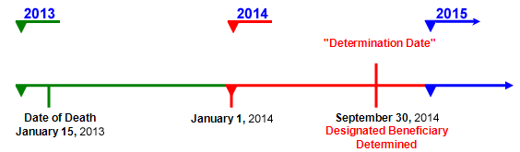

As you can see in the above illustration, the time period between the IRA owner's death and the determination of the designated beneficiary for RMD purposes allows a period of time (at least 9 months) in which there is some potential flexibility in formulating estate planning strategies. There are, however, limitations as to how much these designations can change.

## Limitations on Changing Designated Beneficiaries after Death

Given that the beneficiaries are determined so long after death, it might appear possible to "subvert" the regulations by changing the beneficiary after death, thereby selecting the most advantageous distribution options. While the designated beneficiary is determined on September 30 of the calendar year following the year of death, this does **NOT** provide unlimited flexibility to change the designated beneficiary. ***Only the individual or those individuals named as beneficiaries, or contingent beneficiaries, at the time of death are eligible to be designated beneficiaries.***

However, during the time period between the IRA owner's death and the date in which the designated beneficiaries are determined, the beneficiaries may impact the distributions from the IRA by arranging to:

* Disclaim all or part of their interest in the IRA, or
* Cash out their interest in the IRA through a distribution.

Disclaiming an interest in the IRA before the Determination Date has the same effect as if the disclaiming party has predeceased the IRA owner, thereby being removed from the group of designated beneficiaries. In like manner, if a beneficiary cashes out his or her interest in the IRA through a distribution prior to the determination date, that beneficiary will be removed from the group of designated beneficiaries. In either case, upon the determination date, only the life expectancies of the designated beneficiaries remaining are considered for calculating RMDs.

|  |
| --- |
| **Rule for Changing Beneficiaries After Death**  There are three rules to remember about "changing beneficiaries" after death:   1. Only beneficiaries named before the IRA owner's death are eligible. 2. Eligible beneficiaries may be reduced in number by one or more by disclaiming their interest. 3. Eligible beneficiaries may be reduced in number by one or more by receiving their entire benefit before the Determination Date.   Within these parameters, some postmortem planning is possible, which will be discussed later in this course. |

## Owner's Death BEFORE the RBD (With a Designated Beneficiary) - Non-Spouse Beneficiary

Now that we have examined how final beneficiaries are determined for purposes of computing Required Minimum Distributions (RMD) and how the number of eligible beneficiaries can be reduced for purposes of that computation, we can now look at what happens if the owner dies before the Required Beginning Date (RBD).

Distribution Options for a Non-Spouse Beneficiary

According to IRS guidelines, the distribution options for a non-spouse beneficiary are as follows.

|  |
| --- |
| **Distribution Options for a Non-Spouse Beneficiary**   * **For a sole designated beneficiary**   The RMDs for the beneficiary would be calculated in the year following the year of the IRA owner's death. The life expectancy factor is determined from the IRS Single Life Table by using the beneficiary's attained age in the year after the year of the IRA owner's death. Thereafter, instead of annually returning to the Single Life Table, this life expectancy factor would simply be reduced by one for each subsequent year. Payments under this method must start no later than December 31 of the year following the year of the IRA owner's death.   * **For multiple designated beneficiaries**   If more than one designated beneficiary is named, the life expectancy of the oldest beneficiary is used. However, if separate accounts are established by December 31 of the year following the year of the IRA owner's death, then each separate account would distribute as for a sole designated beneficiary.   * **The "Five-Year Rule"**   If the named beneficiary does not meet the qualifications of a designated beneficiary, the IRA must be fully distributed within five years of the IRA owner’s death. Specifically, with the "five-year rule," the entire balance must be fully distributed by the end of the calendar year that contains the fifth anniversary of the date of the IRA owner's death.  If the beneficiary does qualify as a designated beneficiary, the beneficiary can elect to deplete the IRA within five years of the IRA owner's death rather than using one of the methods above. |

## Owner's Death BEFORE the RBD (With a Designated Beneficiary) - Spouse Beneficiary

If the sole beneficiary is the IRA owner's spouse, the surviving spouse can elect to be treated as an owner of the IRA or as a beneficiary of the IRA. If the surviving spouse is among a number of beneficiaries upon the Determination Date, then the surviving spouse is treated as any other person if there are no separate accounts; however, if there are separate accounts, then the surviving spouse has the same options regarding his or her portion as would be available as the sole designated beneficiary.

The following distribution options are available to the spouse beneficiary.

|  |
| --- |
| **Distribution Options for a Spouse Beneficiary**   * **As an Owner**   After the IRA owner's death, the surviving spouse can elect to be treated as the owner of the IRA. In this case, the surviving spouse could roll over or transfer the assets to his or her own IRA. The surviving spouse can then name new beneficiaries and, if the spouse is under age 70½, annual distributions can be delayed until his or her Required Beginning Date.   * **As a Beneficiary**   If the spouse elects to be treated as a beneficiary of the deceased spouse's IRA, then the surviving spouse has the following options:   * **Make distributions based on the spouse beneficiary's single life expectancy**   The surviving spouse can take annual distributions from the deceased owner's IRA over the surviving spouse's own annually recalculated single life expectancy.   * **Make distributions based on deceased spouses age 70½**   However, rather than basing the required beginning date upon when the surviving spouse turns 70½, the surviving spouse can elect to begin making required minimum distributions in the year in which the deceased spouse would have turned 70½. For example, a surviving spouse who is 5 years older could defer required minimum distributions by making this election.   * **Make distributions based on the "Five-Year Rule"**   Under this option, the surviving spouse can elect to deplete the IRA within five years of the IRA owner's death. |

## Owner's Death BEFORE the RBD (Without a Designated Beneficiary)

If there are no designated beneficiaries upon the death of the IRA owner (e.g., a charity is named as the beneficiary), only one distribution option is available.

|  |
| --- |
| **Distribution Options with No Designated Beneficiary**   * **The "Five-Year Rule"**   The entire IRA balance must be fully distributed by the end of the calendar year that contains the fifth anniversary of the date of the IRA owner's death. |

Estate Planning Strategy Considerations

Since designated beneficiaries are not determined until September 30 of the year that follows the year of the IRA owner's death, there is a window of time that provides some flexibility for postmortem (after death) planning. Such planning is the subject of the next page.

Special Rules when Naming a Trust as Beneficiary

When a trust that meets certain requirements is named as the beneficiary, the ***"look through" rules*** apply. These rules will be discussed in more detail later in the course. Under these rules, the individual beneficiary of the trust is considered to be the designated beneficiary of the IRA for purposes of determining RMDs after the IRA owner's death. If there are multiple beneficiaries of the trust, it is not permissible to use separate accountings for each beneficiary; rather, you must go to the Multiple Individuals (no separate accounts) options, which in the case of death before the RBD would require either using the oldest beneficiary's single life expectancy or the "five-year rule."

## Required Minimum Distributions (RMDs) for Roth IRAs

|  |
| --- |
| Exception  Assume that the surviving spouse is the sole beneficiary of the decedent spouse’s Roth IRA. The surviving spouse may:   1. Avoid RMDs altogether by treating the inherited Roth IRA as his or her own 2. Delay RMDs until the decedent spouse would have attained age 70½ . |

Given that Roth IRAs do not have a required beginning date during the original owner’s lifetime, this raises the question as to what rules will apply for required distributions of Roth IRAs after the death of the owner.

The answer is that the rules that are applicable to beneficiaries of Roth IRAs are generally the same rules that apply to Traditional IRAs when the Traditional IRA owner dies prior to the required beginning date. **Click** here **for an example.** There is an exception if the sole beneficiary is the surviving spouse.

|  |
| --- |
| Example  Sylvia died at the age of 78 and was the owner of a Roth IRA. The sole beneficiary of her Roth IRA is her daughter Sarah who was 56 at the time for Sylvia's death.   * Had this been a Traditional IRA, the required distribution rules applicable to death after the required beginning date would be used. * However, since this is a Roth IRA, the rules that are used are the same rules that govern required distributions from traditional IRAs where the owner dies before the required beginning date.   Thus, the daughter's required distributions will be based upon either of the following:   * The "five year" rule. * The life expectancy of the daughter, determined by her attained age in the year after her mother's death. |

## Postmortem Planning (Owner's Death BEFORE the RBD)

Between the time of the owner's death and the Determination Date, there is the possibility of postmortem (after death) planning that can enhance the tax-deferred benefit of the IRA. Essentially, there are three ways in which postmortem planning can affect the calculation of the required distributions.

|  |
| --- |
| **Separate Accounts** |
| When multiple beneficiaries are named and the beneficiary designation provides for the creation of separate accounts, using separate accounts can enhance the tax-deferral benefit. Creating separate accounts by December 31 of the year after the year of the IRA owner's death allows each beneficiary to take annual RMDs based on his or her own single life expectancy. This is useful in cases where there is a discrepancy between the ages of the beneficiaries. However, separate accounts cannot be used if one of the beneficiaries on the Determination Date is an entity that does not satisfy the "look through" rules. |
| **Disclaim** |
| For those families where the goal is to extend the life of the tax-deferred advantages of the IRA, the older beneficiaries can disclaim all or part of their share of the IRA benefit prior to the Determination Date, leaving it for the younger remaining beneficiaries, or contingent beneficiaries. The rationale for this tactic is that younger beneficiaries have a longer life expectancy, which would result in a smaller RMD amount, thereby allowing more of the IRA to remain intact and to continue its tax-deferred growth (i.e., “stretching the IRA”). Note that disclaiming treats the disclaiming beneficiary as if he or she has predeceased the IRA owner. The resulting beneficiaries will be determined based on the IRA document, not the disclaiming beneficiary. Therefore, before using this technique it is wise to examine the IRA document for contingent beneficiary identification.   |  | | --- | | **Mr. Sanford**  William Sanford had an IRA with a balance of $2.1 million. His wife, Judy, is 72 and is his named designated beneficiary. His children, David and Lauren, are the contingent beneficiaries, and would have been the designated beneficiaries if Judy had already died.  William died of a heart attack on January 15, 2013. Under the RMD rules, the designated beneficiaries are determined on September 30, 2014. If Judy has other assets available to her and does not need the IRA assets for her financial stability, she may want to consider disclaiming her share and allowing the assets to be passed to the children as the contingent beneficiaries. When the Determination Date arrives, the children will be recognized as the designated beneficiaries and the payout will be based on their longer life expectancy. Furthermore, if separate accounts are used, David and Lauren may take distributions based on each individual life expectancy. This will significantly slow the rate at which the assets are removed. | |
| **Total Distribution to Entities** |
| When there is a mixture of individuals and entities (e.g., charities and trusts) named as beneficiaries, it may be advantageous to make full distribution to the entities prior to the Determination Date. Since these entities may not meet the "look through" rules, the full amount of the IRA would otherwise have to be distributed within 5 years. By making full distribution to the entities prior to the Determination Date, only individuals will be recognized as the designated beneficiaries and the IRA can be distributed according to the life expectancy of the oldest beneficiary or, if separate accounts are created, according to each individual's own life expectancy. |

## Review of Options (Owner's Death BEFORE the RBD)

The following chart provides an overview of the options available when the IRA owner dies before the Required Beginning Date:

**Distribution Options for Death BEFORE the Required Beginning Date**

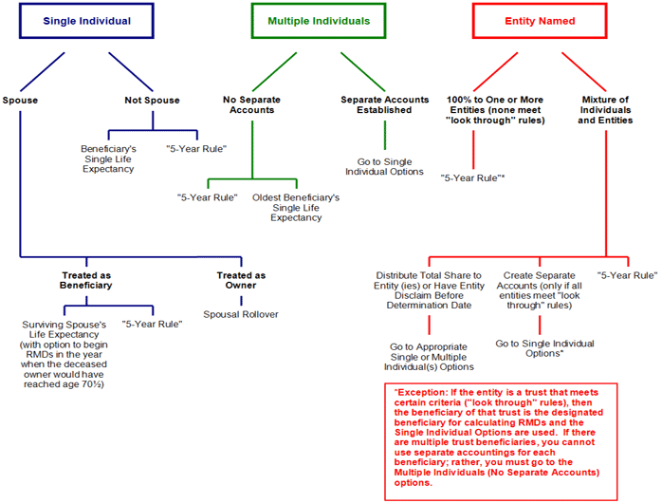

## Review Exercise

Before proceeding, it is important to make sure you clearly understand the important terms and rules discussed so far. For each of the terms below, first define each in your own mind, including its significance, then click on each term for further understanding and clarification.

|  |
| --- |
| **Required Beginning Date** |
| **Definition** - This is the date by which required minimum distributions must begin. It is April 1 of the calendar year following the year the IRA owner attains age 70½.  **Significance** - The owner must make the initial Required Minimum Distribution (RMD) by this date. Whether the owner's death is before, on, or after this date changes the distribution options available to beneficiaries. |
| **Determination Date** |
| **Definition** - This is the date when beneficiaries are determined for an IRA. It is September 30 of the year following the calendar year in which the IRA owner died.  **Significance** - This is the date by which it is determined whether the IRA owner's beneficiaries are designated beneficiaries. |
| **"Five-Year Rule"** |
| **Definition** - This is an after-death distribution methodology whereby all assets in the IRA must be completely distributed to the IRA beneficiary(ies) as of December 31 of the calendar year that contains the fifth anniversary of the date of the IRA owner's death.  **Significance** - This rule is only used if death occurs BEFORE the RBD. This rule must be followed if there are no designated beneficiaries; it is optional in all other situations. |
| **"Single Life Expectancy Rule"** |
| **Definition** - This is an after-death distribution option whereby the IRA proceeds are paid to the appropriate beneficiary(ies) based on the beneficiary's(ies') life expectancy. If only one individual is the beneficiary, it utilizes the single life expectancy of that beneficiary; if multiple individuals are the beneficiaries, it uses the single life expectancy of the oldest beneficiary (unless separate accounts are established by December 31 of the year following the year of the IRA owner's death).  **Significance** - It may be more advantageous for the beneficiaries to establish separate accounts and receive RMDs based on each beneficiary’s own life expectancy. |
| **Separate Accounts** |
| **Definition** - When an IRA owner dies and multiple beneficiaries are designated, separate accounts may be established for each beneficiary, thereby providing each beneficiary more flexibility to determine the distribution methodology.  **Significance** - The accounts must be established by December 31 of the year following the year of the IRA owner's death, with funding based on each individual's pro-rata share of the inheritance, and should provide for separate accounting of all gains and losses for each account. Choosing this strategy, each individual is allowed the flexibility to calculate their distribution alternatives separately under the rules established for a single person beneficiary. |

## Death ON or AFTER the Required Beginning Date

If the IRA owner dies on or after the Required Beginning Date (RBD), then any Required Minimum Distribution (RMD) that had yet to be removed by the owner for the year of death must be removed by the beneficiary(ies) prior to the end of that year. Beginning with the year after death, the options for the beneficiaries are somewhat different than they were if death occurred before the owner reached the RBD.

Similar to the previous discussion, there are three potential beneficiary designations that are considered.

* Single Individual
* Multiple Individuals
* Entities (Trusts, charities or the like)

We will detail each beneficiary and the options they have on the following pages.

## Owner's Death ON or AFTER the RBD (With a Designated Beneficiary) - Non-Spouse Beneficiary

According to IRS guidelines, the distribution options for a non-spouse beneficiary are as follows.

|  |
| --- |
| **Distribution Options for Non-Spouse Beneficiary**   * **RMDs based on the non-spouse beneficiary's single life expectancy**   The RMDs for the beneficiary would be calculated in the year following the year of the IRA owner's death. The life expectancy factor is determined from the IRS Single Life Table by using the beneficiary's attained age in the year after the year of the IRA owner's death. Rather than annually returning to the Single Life Table, this life expectancy factor is then reduced by one for each subsequent year. Payments under this method must start no later than December 31 of the year following the year of the IRA owner's death.   * **RMDs where the beneficiary is older than the IRA owner**   If the designated beneficiary was older than the deceased IRA owner at the time of death, RMDs may be based on the deceased IRA owner's remaining single life expectancy. This will result in a smaller RMD amount if the beneficiary was more than a year older. The remaining life expectancy is determined as of the deceased owner's birthday in the year of death and reduced by one each subsequent year after death.   * **If Multiple beneficiaries**   If more than one designated beneficiary is named, then the longer of the life expectancy of the oldest beneficiary or the deceased owner's remaining life expectancy is used (unless separate accounts are established by December 31 of the year following the year of the IRA owner's death). |

## Owner's Death ON or AFTER the RBD (With a Designated Beneficiary) - Spouse Beneficiary

According to IRS guidelines, the distribution options for a spouse beneficiary are as follows.

|  |
| --- |
| **Distribution Options for a Spouse Beneficiary**   * **Roll over or transfer to spouse's own IRA**   After the IRA owner's death, the spouse can roll over or transfer the assets to his or her own IRA. The spouse can then name new beneficiaries. Also, if the spouse is under age 70½, annual distributions can be delayed until his or her Required Beginning Date.  *Note: If the spouse beneficiary is younger than 59½ and needs to take distributions for current income, they may not want to roll the assets over to his or her own IRA since the distributions may be subject to the 10% penalty. Instead, the spouse should establish an inherited IRA and take RMDs based on the deceased spouse's life expectancy so that the 10% penalty would not apply to those distributions.*   * **RMDs based on the spouse beneficiary's single life expectancy**   The spouse can take annual distributions from the deceased owner's IRA over the surviving spouse’s single life expectancy.   * **RMDs where the spouse beneficiary is older than the IRA owner**   If the spouse beneficiary is older than the IRA owner, RMDs may be based on the IRA owner's remaining single life expectancy. This would result in a smaller RMD amount than if the spouse's single life expectancy was used. The remaining life expectancy is determined as of the deceased owner's birthday in the year of death and reduced by one each subsequent year following death. |

## Owner's Death ON or AFTER the RBD (Without a Designated Beneficiary)

If there are no designated beneficiaries upon the death of the IRA owner, as would occur in naming an entity that does not satisfy the "look through" rules, only one distribution option is available.

|  |
| --- |
| **Distribution Option with No Designated Beneficiary**   * **RMDs based on the deceased IRA owner's remaining single life expectancy**   If there are no designated beneficiaries, the IRA balance must be distributed over the IRA owner's remaining single life expectancy. This is obtained from the IRS Single Life Table by using the IRA owner's attained age in the year of death, and is reduced by one for each subsequent year. These distributions must begin by December 31 of the year following the year of the IRA owner's death. |

If the entity is a trust that meets certain criteria ("look through" rules), then the beneficiary of that trust is the designated beneficiary for calculating RMDs. If there are multiple trust beneficiaries, you cannot use separate accountings for each beneficiary; rather, you must go to the multiple individuals (no separate accounts) options, which for deaths occurring on or after RBD would mean selecting distributions based on the LONGER of the oldest beneficiary's single life expectancy or the deceased owner's remaining single life expectancy.

## Review of Options (Owner's Death ON or AFTER the RBD)

The following chart provides an overview of the options available when the IRA owner dies after reaching the Required Beginning Date:

**Distribution Options for Death ON or AFTER the Required Beginning Date**

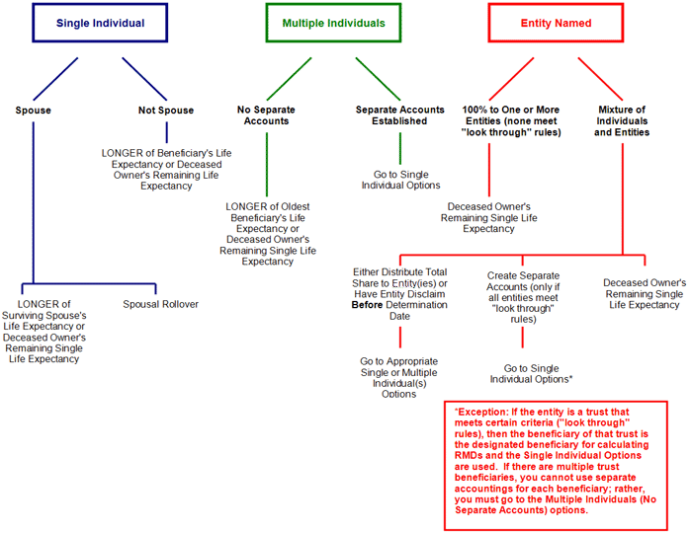

In any situation, the RMD for the year in which the IRA owner died is still due. The beneficiary must make that distribution before December 31 in the year of the death if the deceased owner had not already made the distribution for that year prior to death.

## Top Choices for a Designated Beneficiary

While every situation is different, and each case requires specific analysis, the following is intended to provide general thoughts on the most commonly effective choices for a designated beneficiary.

Spouse

In many cases, the spouse is named as the primary beneficiary for any retirement plan assets or IRA. In fact, if the assets are held in a qualified plan such as a 401(k), the spouse is generally entitled to 50% of the assets unless spousal consent is provided to name other beneficiaries. There is, however, a potential problem that surfaces when the couple has a significant amount of their net worth in the IRA assets. In this case, they may need to use their IRA to fund a Credit Shelter Trust. Typically, in these situations it is preferable to name the spouse as the primary beneficiary and the trust as the contingent beneficiary. This allows the surviving spouse the flexibility of choosing to establish his/her own IRA with the proceeds or simply disclaim the interest to allow the trust to become the beneficiary.

|  |
| --- |
| **Credit Shelter Trust**  Every individual is provided with a credit against estate taxes. A common estate planning technique for large estates is to fund a Credit Shelter Trust upon the first spouse's death with those assets that can be protected from taxation by use of the applicable estate tax credit amount. The balance of the estate can then be transferred to the surviving spouse and be protected from estate taxation by applying the unlimited marital deduction. Through this method, there is no estate tax upon the death of the first spouse and the estate tax bill upon the second spouse's death will be lower because the Credit Shelter Trust assets will not be included in the surviving spouse's estate. |

Grandchildren / Younger Generation Individuals

In cases where there is no spouse and the goal is to extend the life of the IRA and provide for the future of another generation, the designated beneficiary could be either grandchildren or other younger individuals. It is important, however, to consider the impact of Generation Skipping Transfer Taxes and the most effective utilization of the GST Exemption when naming younger generation individuals as designated beneficiaries of the IRA.

|  |
| --- |
| **Generation Skipping Transfer (GST) Taxes**  The Generation Skipping Transfer (GST) tax is imposed on transfers of property to “skip persons”. Skip Persons are defined as individuals who are two or more generations below that of the person transferring the property. |

The benefit of this strategy relates to the minimization of Required Minimum Distributions, as these payouts are calculated on the life expectancy of the grandchild. The disadvantage is the fact that if multiple beneficiaries are named, the payouts upon the death of the owner will be based on the oldest beneficiary. To avert this, the IRA can be segmented into separate accounts, each with a single beneficiary, thereby providing the ultimate in flexibility for each specific beneficiary.

## Other Choices for a Designated Beneficiary

Trust

Naming a trust as the beneficiary can be a complex undertaking. The regulations explicitly state that a trust must meet some very specific requirements ("look through" rules) in order for the beneficiaries of the trust to be regarded as designated beneficiaries. Otherwise, the IRA is treated as having no designated beneficiaries and the required distributions will be computed as with any other entity.

|  |
| --- |
| The specific criteria ("look through" rules) that must be met to provide the trust beneficiaries the status of Designated Beneficiaries are:   1. The trust must be valid under state law (or would be if it was funded). 2. The trust must be irrevocable or will become irrevocable at the death of the owner. 3. The trust instrument must clearly identify the beneficiaries, who must be within the definition of a designated beneficiary. 4. The plan administrator or custodian must be provided with specific documentation pertaining to the trust, such as the following:  * A ***copy of the trust document and any amendments***, such amendments being delivered to the plan administrator or IRA custodian by October 31 of the year following the year of the owner's death, or * A ***list of all beneficiaries of the trust,*** including contingent beneficiaries and remainder beneficiaries, with descriptions of the provisions for their entitlement.   Compliance with these requirements is much more complicated than might first appear. For example:   * How are contingent beneficiaries and remainder beneficiaries treated? * What happens if income and principal is at the trustee's discretion? * What is the effect of a charity being named as a remainder beneficiary? * What is the effect of the surviving spouse being the sole income beneficiary?   It is beyond the scope of this module to resolve such issues. Simply be aware that they do exist. Nonetheless, a properly drafted trust can expand the IRA distribution options beyond those normally permitted for entities. |

Charitable Organization

The IRA owner may desire to use the IRA assets for charitable purposes upon death. This could be accomplished by naming the charity as a beneficiary. However, given that the charity has no life expectancy, it cannot be a "designated beneficiary." In this case, the slowest available payout is based on the fixed term life expectancy of the IRA owner as of the year of his/her death (if death occurs on or after RBD), or upon the Five-Year Rule if death occurred before reaching the Required Beginning Date.

## Review Exercise

Select the correct answer to each question.

1. **Which of the following diagrams depicts the distribution methodologies available to a surviving spouse when the deceased IRA owner dies AFTER reaching the Required Beginning Date (RBD)?**

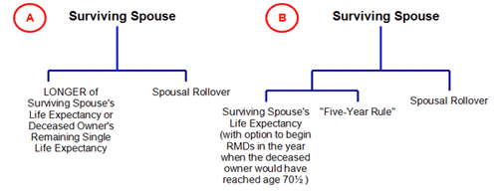

* Diagram A
* Diagram B

1. **The following chart depicts the options available for Multiple Beneficiaries if death of the owner occurs before the Required Beginning Date. Select the two options available if no separate accounts are created:**

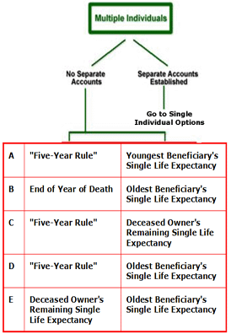

* Choice A
* Choice B
* Choice C
* Choice D
* Choice E

1. **The following charts depict the options available if the sole beneficiary is a charity. From the options given, select whether death occurred before or after the required beginning date.**

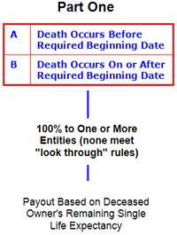

* Choice A
* Choice B

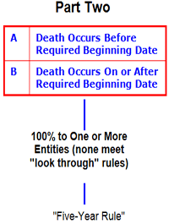

* Choice A
* Choice B

1. **The following chart depicts an IRA with a mixture of individuals and a Trust with multiple beneficiaries that satisfies the "look through" rules. Complete the chart with the following proper options:**

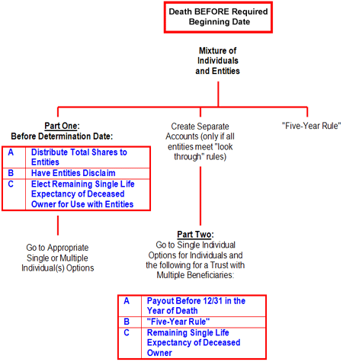

**Part One:**

* Choice A
* Choice B
* Choice C
* Choices A and B
* Choices B and C

**Part Two**

* Choice A
* Choice B
* Choice C

1. **The following chart depicts an IRA with a mixture of individuals and entities as beneficiaries and death after RBD. Complete the chart with the proper option:**

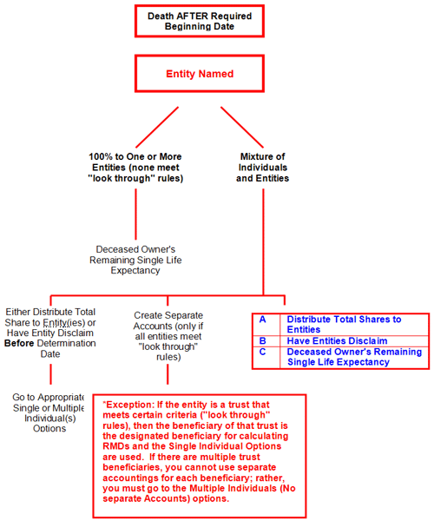

* Choice A
* Choice B
* Choice C

The answers to these questions are found on the following page.

## Review Exercise – Answer Key

Select the correct answer to each question.

1. **Which of the following diagrams depicts the distribution methodologies available to a surviving spouse when the deceased IRA owner dies AFTER reaching the Required Beginning Date (RBD)?**



* **Diagram A**

**Correct**. The Five-Year Rule is only applicable if the deceased spouse has not yet reached the Required Beginning Date.

* Diagram B

**Incorrect**. The Five-Year Rule is only applicable if the deceased spouse has not yet reached the Required Beginning Date.

1. **The following chart depicts the options available for Multiple Beneficiaries if death of the owner occurs before the Required Beginning Date. Select the two options available if no separate accounts are created:**



* Choice A

**Incorrect.** Try again

* Choice B

**Incorrect.** Try again

* Choice C

**Incorrect.** Try again

* **Choice D**

**Correct**.

* Choice E

**Incorrect.** Try again

1. **The following charts depict the options available if the sole beneficiary is a charity. From the options given, select whether death occurred before or after the required beginning date.**



* Choice A

**Incorrect**.

* **Choice B**

**Correct**.



* **Choice A**

**Correct**.

* Choice B

**Incorrect**.

1. **The following chart depicts an IRA with a mixture of individuals and a Trust with multiple beneficiaries that satisfies the "look through" rules. Complete the chart with the following proper options:**



**Part One:**

* Choice A

**Incorrect**. Try again.

* Choice B

**Incorrect**. Try again.

* Choice C

**Incorrect**. Try again.

* **Choices A and B**

**Correct**.

* Choices B and C

**Incorrect**. Try again.

**Part Two**

* Choice A

**Incorrect**. Try again.

* **Choice B**

**Correct**.

* Choice C

**Incorrect**. Try again.

1. **The following chart depicts an IRA with a mixture of individuals and entities as beneficiaries and death after RBD. Complete the chart with the proper option:**



* Choice A

**Incorrect**. Try again.

* Choice B

**Incorrect**. Try again.

* Choice C

**Incorrect**. Try again.

## Conclusion

This concludes the material for this subject. At this time you may return to any sections in which you feel the need for further study.